Wraps and Sandwiches with Soup
Roast Beef, Swiss, Red Onion and Horseradish Mayo
Turkey & Swiss Croissant
Ham, Cheddar and Mustard
Balsamic Glazed Chicken & Sundried Tomato
Chicken Caesar Wrap
Grilled Vegetable Sandwich
Chicken Salad Croissant
Southwest Chicken Wrap
BLT
Chicken Club wrap
Soups
Tomato
Broccoli Cheese
Cream of Mushroom
Vegetable Beef
Beef Stew
Chicken Noodle
Hungarian Mushroom
Cheddar Beer
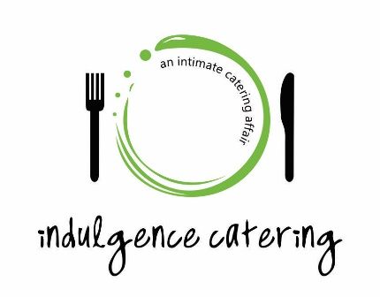
Beef/Pork on a Bun with Salad
Baked Potato Bar with Salad
Turkey with gravy, stuffing, potatoes, vegetable and one salad
Roast Beef with gravy, potatoes, vegetable and one salad
Pasta with Salad and Bread
*Choose from Chicken Penne Alfredo with Brocoli, Chicken Spaghetti, Spaghetti with Meat Balls or Meat Sauce, Lasagna, Roasted Vegetable with Goat Cheese and WholeWheat Pasta or Four Cheese Pasta Shells with Roasted Tomatoes
Baked Chicken Parm with pasta and one salad
Pork Tenderloin with Roasted Potatoes, Vegetable and one Salad
Stuffed Chicken Breast with Potato, Vegetable and one Salad
Pork Stir-Fry with Rice and one Salad
Above is perfect for lunches. Add a salad, side and dessert for prices noted on the following pages for an evening meal

Sides
Grilled Asparagus w/ Lemon Butter
Roasted Root Vegetables
Butternut Squash w/ Sweet Honey Butter
Garlic Mashed Red Potatoes
Caramelized Sweet Potatoes
Saffron Rice
Twice Baked Potatoes
Chive Horseradish New Potatoes
Sautéed Zucchini, Yellow Squash, Baby Carrot w/ Fresh Thyme and Oregano
Fresh Sautéed Green Beans w/ Sweet Peppers

Salads

Spinach Salad
Fruit Salad
Greek Salad
Broccoli Salad
Garden or Cesar Salad
Asian Noodle Salad
*Above is included in meals listed above, below is an additional charge
Chef Salad
Grilled Chicken Salad
Thai Chicken Salad
Santa Fe Chicken Salad
Buffalo Chicken salad
BLT Cobb Salad
Chicken Caesar
Chicken Salad Supreme

Hor d’evoures
(not limited to this list – ask about selection)
Rumaki – marinated bacon wrapped water chestnuts
Spinach Artichoke dip – Served hot with taco chips
Brie walnut dip – Served hot with bread
So Very Berry Brie Dip – Served hot with bread
Meatballs – Italian, sweet & sour, mushroom sauce
Stuffed Mushrooms – Crab or sausage
Caprese Skewers – Fresh mozzarella, fresh basil and tomatoes with a balsamic vinegarette drizzle
Fresh Salsa or Guacamole and chips
Cuccumber Cups – various selection
Tea Sandwiches – various selection
Grilled Vegetable Crustini – served at room temperature
Grilled Garlic Shrimp - served chilled with aoli or seafood sauce
Baked Goat Cheese Dip – served with tortilla chips
Chicken Cesar Bites –Skewers of Chicken Breast

Desserts
Sex in a pan, Cheesecake variations, Fruit flan, Angel food cake with fresh fruit and whip cream, Trifles………endless possibilities
Ask about our petite dessert selection

Trays

Fruit
Vegetable and dip
PinWheels - deli meat or fruit spread
Meat and cheese
Antipasto platter
Cheese and cracker platter

Prices subject to change without notice on all menu items

